How to start with base tic-tac-toe React code to make new changes
Requirements
- Have some familiarity with HTML, CSS, or JS and if not, then brush up on some of the reference materials from W3Schools provided on the site
- Also take a look at some of the additional materials for learning React as well
- A computer with WiFi
- Already established GitHub account
- An IDE such as Visual Studio Code to develop code in

Part 1 – Where do I get this base code from?
If you haven’t used GitHub before, that’s completely okay! However, for this tutorial, I’m going to assume that you have an account set up at least. So if you do, then you should go to this link below to get the template:
https://github.com/olivia1117/lewis-tac-toe-base
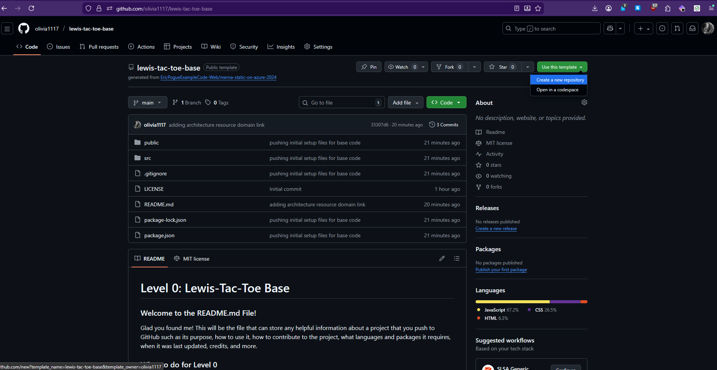
Once here, click on the green button that says Use this template and then select Create a new repository.
You should see a new screen pop up that looks like this:

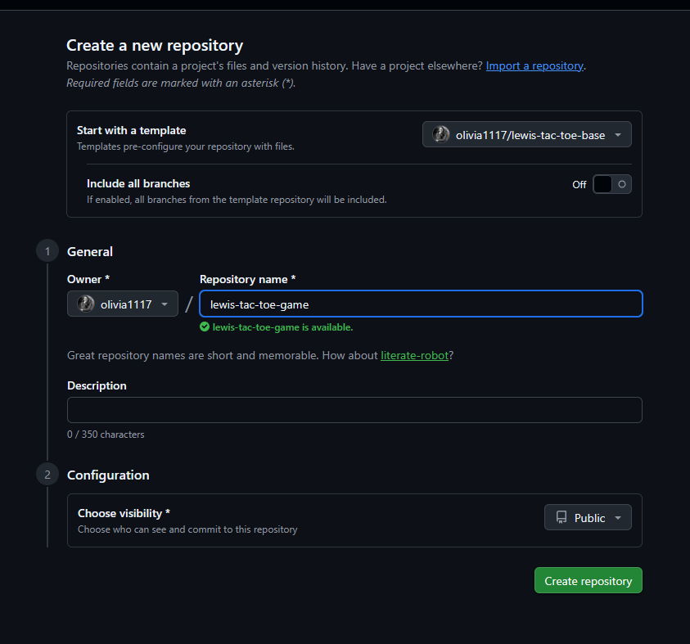
All you need to do here is to enter a unique repository name that you haven’t used for a previous project in your account. Set it to public visibility for now and then click Create repository at the bottom.
Then once that’s done, then you should be able to see your new repository created in your account with the base code from the template repository you used

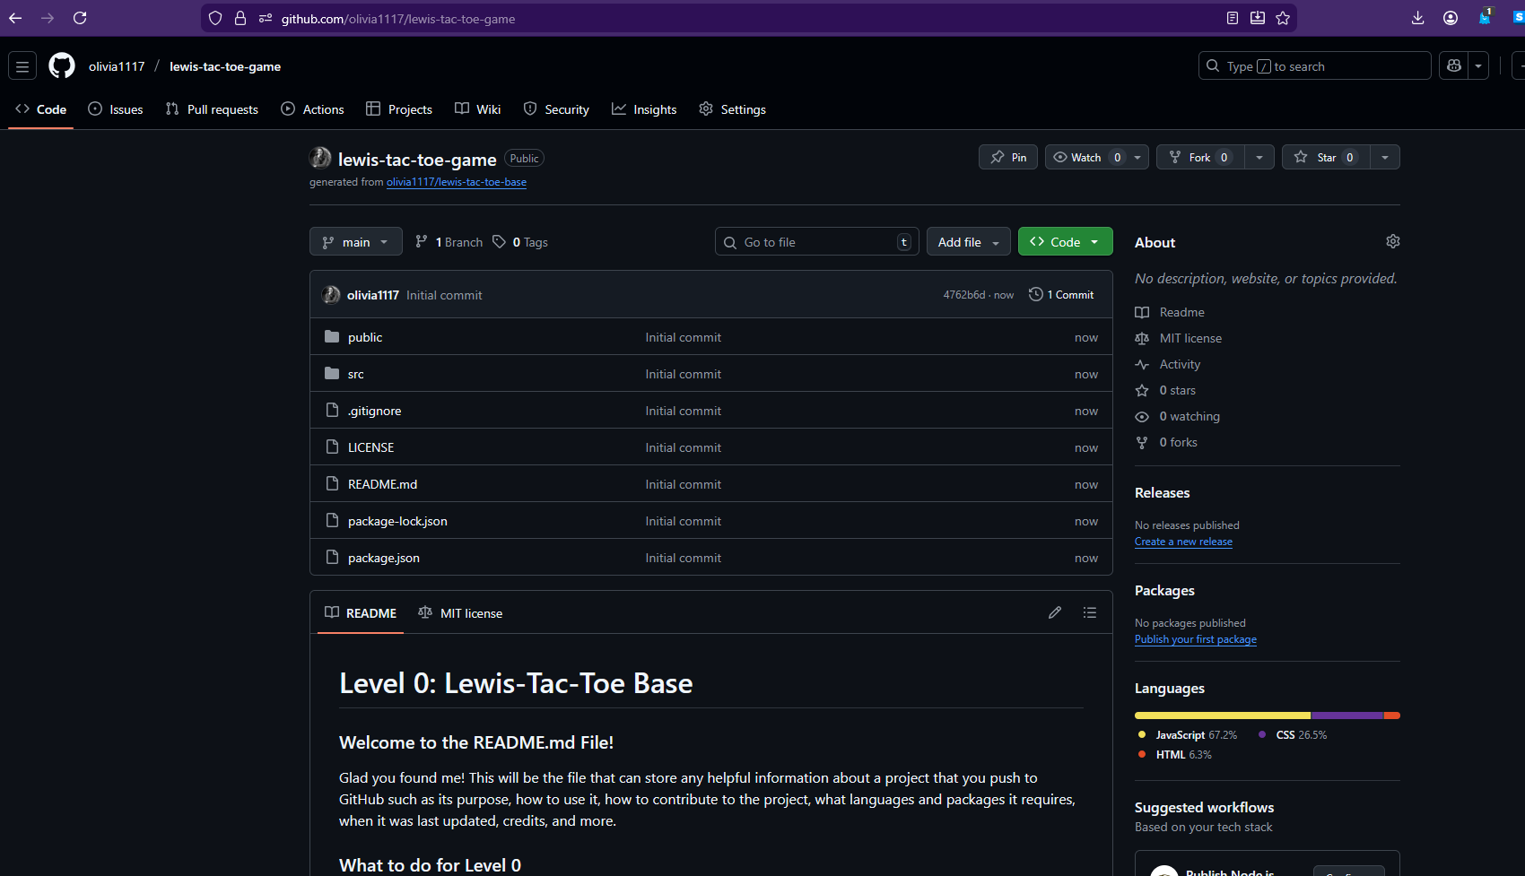
Now, this is the view of your project on the web repository. As a developer, you should be able to have access to the code locally on your machine so you can add onto it, delete from it, and test it without breaking your current version online. For now, let’s call the online current version the Production version. In a development setting working with other programmers, you will have a Production version of your work that everyone is contributing to and that other clients rely on to do their jobs. If Production breaks, that’s very bad because it can cost a lot of time and money to get it back up again. This is why learning some of the basics of cloning a repository and testing locally before pushing new updates to Production is HUGE. You don’t want to be that person whose *oopsie daisy* becomes the problem for everyone else.

Part 2 – How can I get this code to my machine?
Now, with that being said, we’re going to clone this repository to our machine by clicking on the green Code dropdown button and then copying the URL to your clipboard
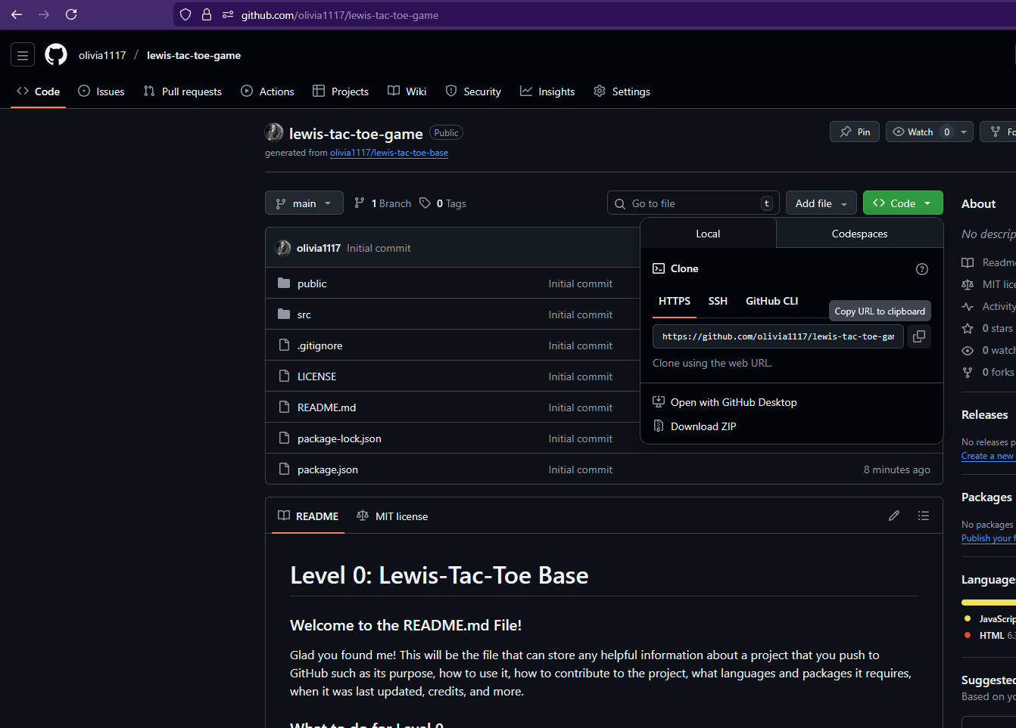
Then, you’ll want to open up some sort of terminal. I prefer to use a separate Git Bash terminal that you can find more information about here:
https://gitforwindows.org/
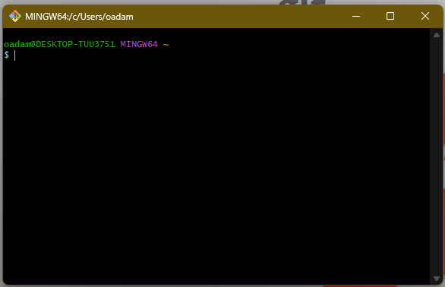
You could also use your CMD or Command Prompt here as well if you’re working on Windows. Sorry Mac peeps! I don’t have a tutorial for people who refuse to leave their cushioned closed tech ecosystem and enter the magical world of literally any other PC. You might be able to follow along somewhat with whichever terminal you guys have and then look up some of the specifics for your machine.
If you have Git Bash open like me, then you’ll see this blank terminal with your username and computer name at the top:
Then, assuming you are already in a default location that is okay to save folders and files to that can be easily accessed, you want to type in the following git clone command and then paste in the URL from your online Production repository from earlier
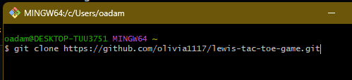
Then click enter and then you’ll see it work its magic and then say Done!
You now have a place on your machine to work on your project!

Part 3 – What’s the big deal about having this on my machine to work from?
We’re going to explore this more after we open Visual Studio Code (or another IDE of choice) and then select Open Folder…
From there you want to make sure you are in the same location on your machine that you cloned into (in my case, it was my user folder oadam, but it shows up as my full name at the top). Then, you want to type in the name of the repository you created such as lewis-tac-toe-game and then select the folder
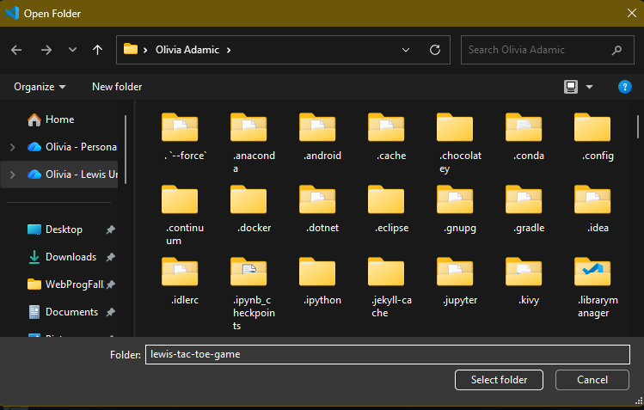

Now you’ll see all these files pop up in your side menu. These are all the files from your online Production repository and we can now edit them here and test them out!
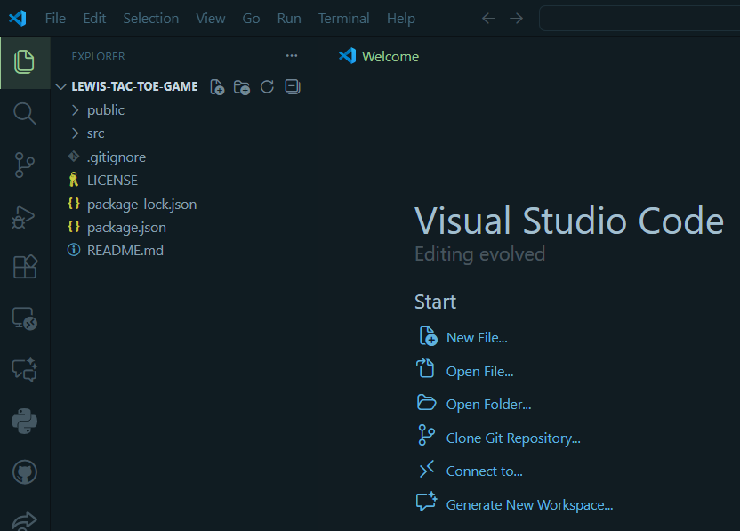
For example, lets open up the public folder and take a look at the index.html file
You might see it’s pretty plain looking and that’s fine because we don’t really want too much on this page. Take a look at some of tags and see if you recognize any if you reviewed the W3Schools content.
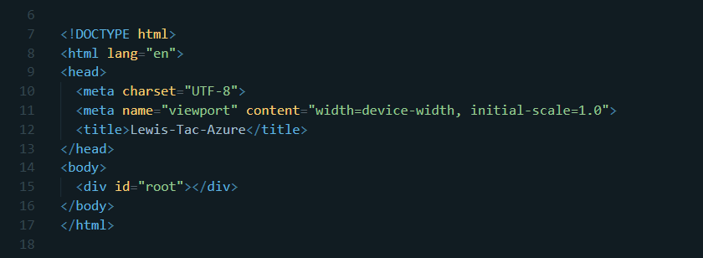
For example, in the html tags, we’re setting the language to English, we’re setting the name as Lewis-Tac-Azure in the title tags, and then using the div tags to specify the id as root which will come into play in just a bit.

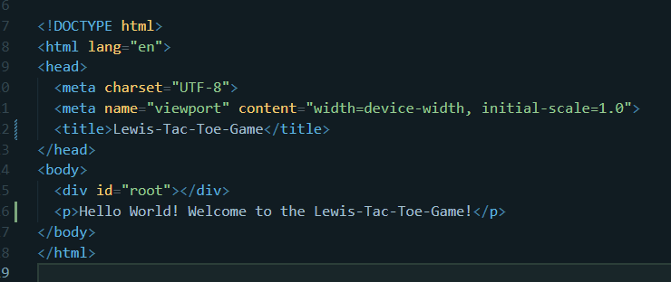
At this step, let’s try to change the name of the application to our new one of Lewis-Tac-Toe-Game. Let’s also add in a little bit of text for good measure too:

Now, we can see what this would look like in a browser very quickly by going back to your file explorer where this whole folder is located and then opening the public folder and then clicking on index.html:
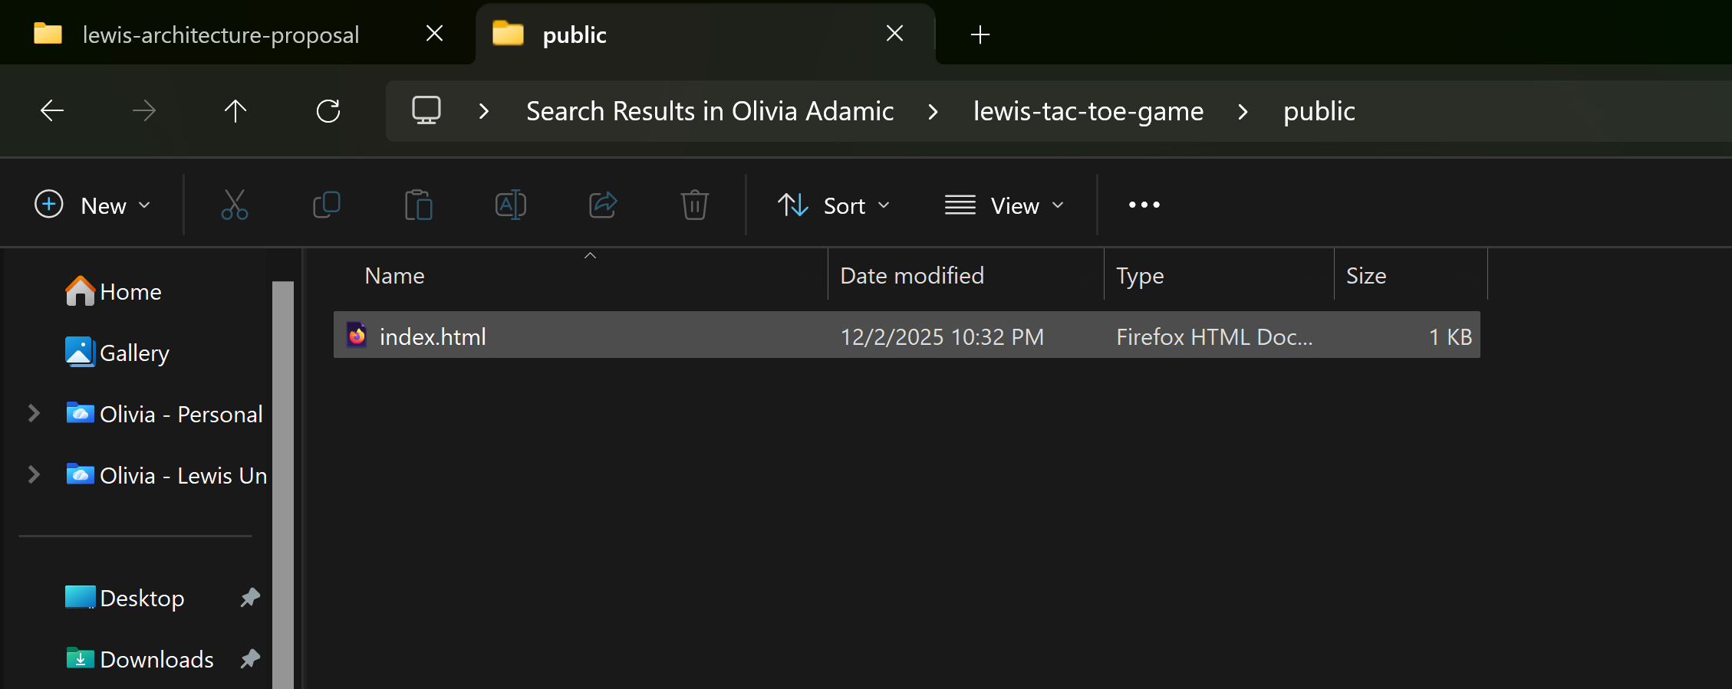
Then it should open your default browser to a simple HTML pages where you can see the tab at the top is the correct name you just changed in the title tags and that little text that you included as well!
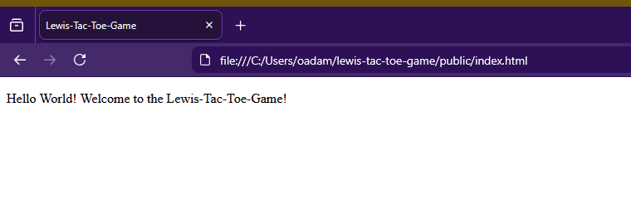
But this isn’t an actual website though! We’ll eventually get to the level where we can do that, but this is a quick way for now to see that things are working.

Part 4 – So what do these other files do?
Let’s take a look at the App.js file now. I’m not going to add a screenshot here because there is a lot of code, but I’ll point out just a few things. The first one is that there are different components in this code such as the Square, Board, and Game. The Square component is responsible for the buttons that can receive a value of X, O, or null and the function within it called onSquareClick is meant to be a callback for when the user clicks the square to trigger the appropriate next actions such as updating the Board component to show one of the values and update the game state.
The Board component is where most of the game logic lives. It handles knowing whose turn it is to put down X or O letters, the states of all 9 squares, and an onPlay function to update the Game component with any moves made. It also can use the calculateWinner(squares) function to determine the winner or next player.
The Game component handles a lot of the states or history of the moves made in the game. It can keep track of the currentMove and then keep creating new versions of the game history and update the board. It also keeps track of the moves made in the game so a user could click on the button to go back to the move they want.
Finally, the calculateWinner(squares) function basically looks at all of the lines on the board and if any of the lines are “winning lines” where there is either all X or O letters, then it returns the winning letter.

Next, let’s discuss what’s happening in the index.js file:
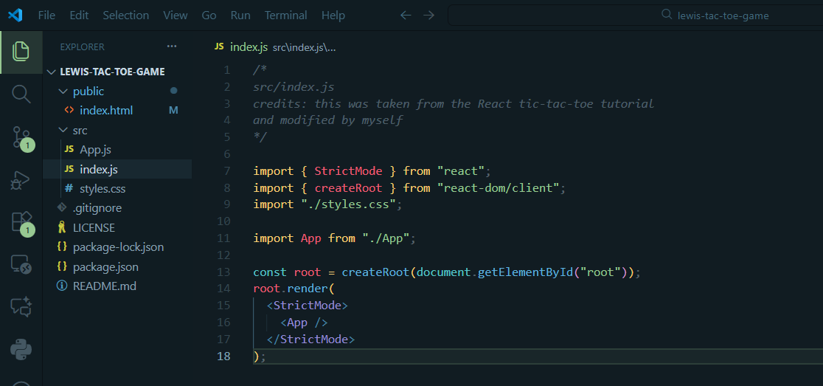
Basically, this file is acting as the file that sort of gets the program up and running. At the top we have a bunch of import statements to get all of the necessary React components that can help with tasks such as creating the root so it can render to the browser using this file and the root element in the HTML file. It also imports other code from our styles.css file to make it pretty and also the game logic code in the App.js file. It will then be able to take all of this code and render the application in the browser.
Finally, the styles.css file handles all of the styling and UI design for our application. Having a simple application that works is important, but creating a good design that makes the user experience or UX better should not be neglected either! We’ll soon look at ways to practice some CSS skills to change up the fonts, color schemes, sizes, and more.
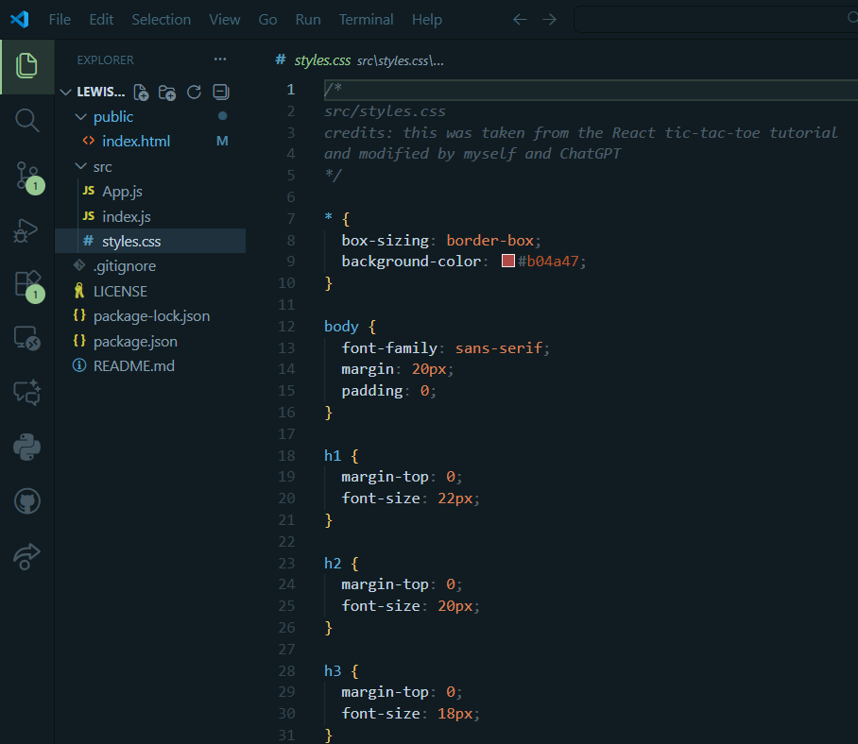

Sorry, I lied to you for those being the final file explanations. There are a few others that are pretty important. I’ll go through them quickly though:
- .gitignore – This is a special type of file that can be handy for developing React apps or even adding some security features. Anything you put in here will be ignored hence .gitignore when you push it to your github repository. In the React context, this is handy because when you build a React app, there usually are a TON of additional packages and files that are needed to render it. However, github usually can’t handle all 10 gajillion files that React wants to generously give you so it can work for various browsers. Usually, they will appear in a folder called node_modules/ or something similar, so you can just put the name of the file or folder you want to ignore here and life will be good!

- LICENSE – When putting open-source code online or just developing in general, it’s a good practice to put some sort of license file with it so that way anyone who wants to use your code knows what is and isn’t okay to do with it like whether they can take it and use it in a product to generate their own profits. There are various ones you can go research on your own, but oftentimes, using an MIT License file as a student works pretty well.

- Package-lock.json – This file is a BEAST and kinda scary looking. All it’s doing in the background is ensuring that everyone who installs your project gets the exact same dependencies and versions so your app doesn’t malfunction on them.
- Package.json – This lists all of the necessary dependencies, scripts, metadata, and configuration for your application. It tells Node and NPM what the project needs and how to run it.

- README.md – This is a handy little file where you can use markdown to explain more about your project so anyone who wants to use it or contribute to it knows its purpose, what languages and packages it uses, credits to any other sources, and more.

Part 5 – Can we just code something already?
Let’s start changing a few things to get some practice with making code changes. Open styles.css and let’s try to add a few blocks of code to change the background color and font-family:
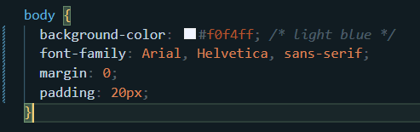
Let’s also change some things for the squares too!
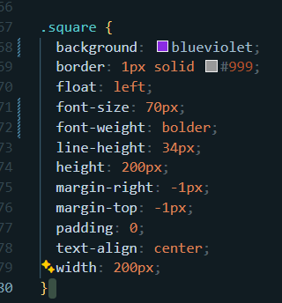

Part 6 –Running and pushing exercises
Now that you’ve played around with a few of the files in this code, let’s build it to see what it looks like locally! This time we’re going to use a different approach.
Go to the top of your IDE and select Terminal New Terminal
Open a new terminal. In this example, I’m using a PowerShell terminal. Then type in the command npm install and hit enter and you’ll see some stuff happening.
**Note: before running this next command, go back to your index.html file and take out the paragraph tags with the “hello world” text within them too.
Once it stops running, open a new terminal and run another command npm start
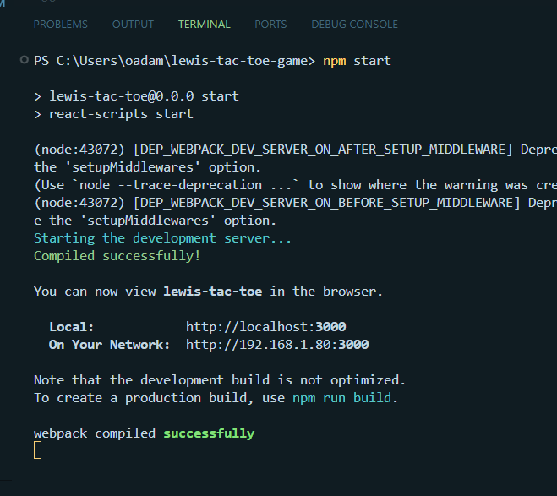
This will start up a new page in your default browser at the localhost:3000 address. If there is an error with this, you might have to research and adjust the settings to use a different port other than 3000 because another application on your computer may already be using it.

This is what your page should look like below with all of the styling modifications we did:

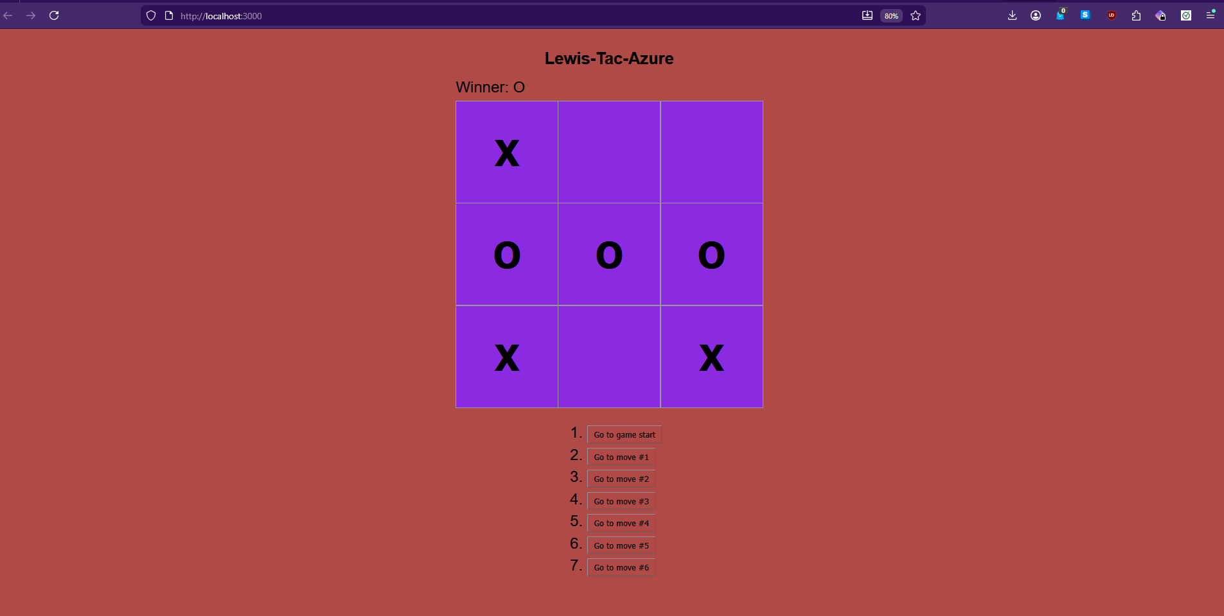
The letters won’t appear on the board until you actually start clicking around on the page.
But now, this is great and all, but let’s push our new changes to the Production repository if we like them! We can do this by going to the source control section, describing our changes in a commit message, and then selecting commit and push from the dropdown.
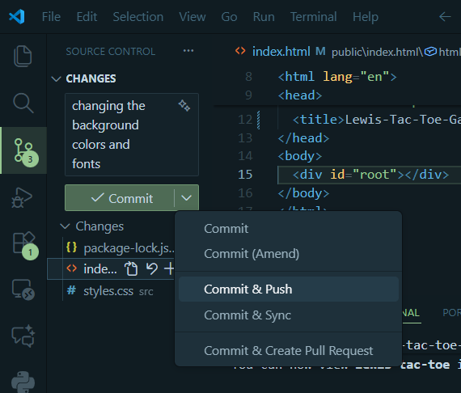

In a minute or so, go back to your Production repository page and see if the changes have been made:
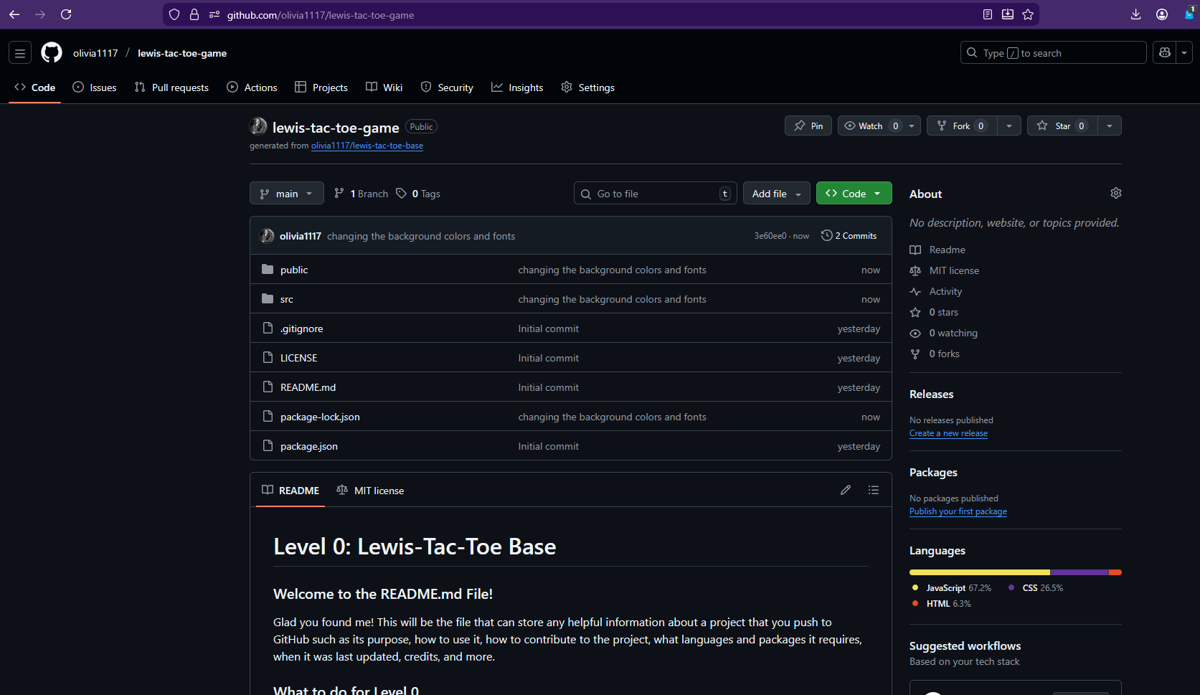
If the changes were successful, you should see the new comments added to the files and you can even click within them to view the code and double check that they have been changed.
If everything looks good then congrats! You just learned some of the basics of GitHub, how to work with repositories, some basics of HTML, CSS, and JS, and a little bit of React! Feel free to go back to the main resources page and go to the next level if you’re ready for a new challenge.

